How to Join Jesus the Whole Truth Bible Study Live:

From a computer/laptop/desktop:
- Navigate to www.jesusthewholetruth.com
- Click on ‘links to join live’
- Ensure the correct link is clicked (Tuesday and Thursday have different links):
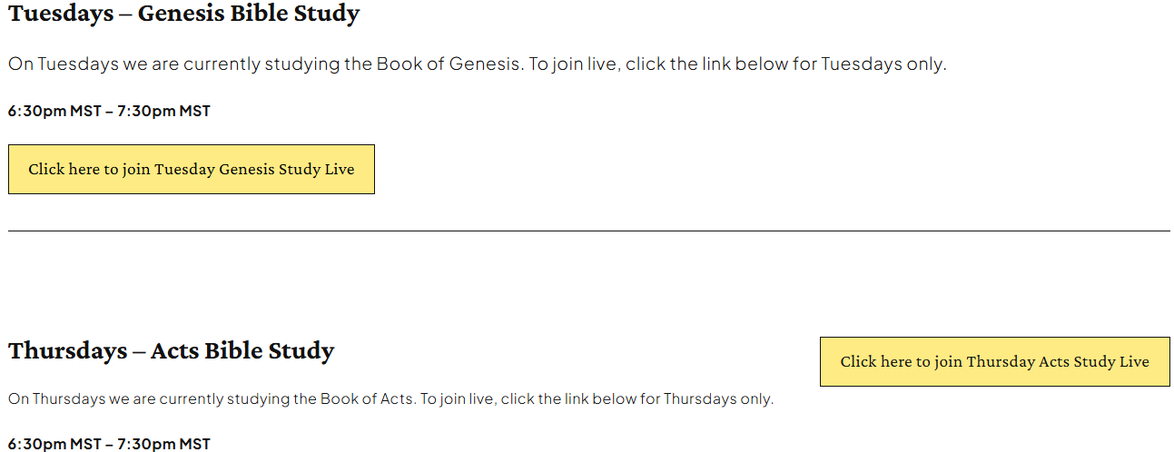
- Once you click the link to join, you will see this notification:
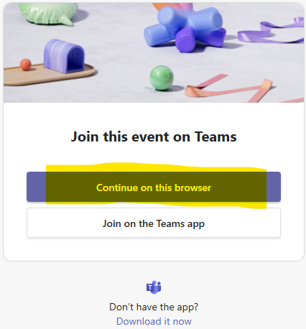
- Click on ‘continue on this browser’ if you are on a computer, then click ‘allow’ if needed for microphone and camera permission:
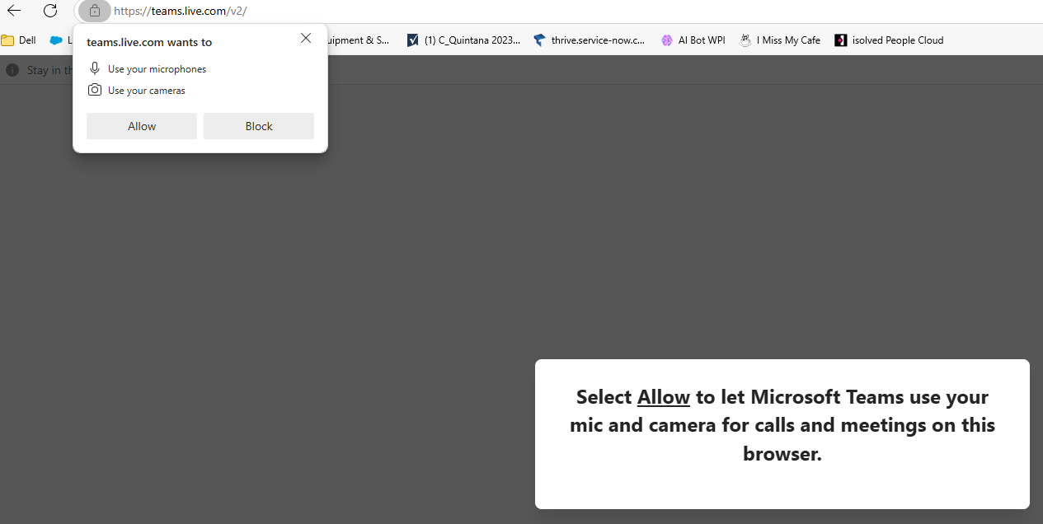

- Type your name, and click ‘join now’
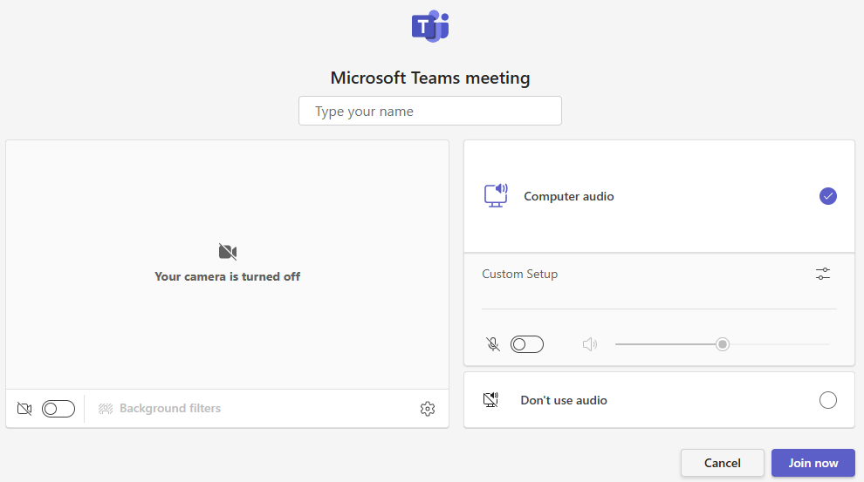

NOTE: how to turn microphone on and off
- Once joined, the highlighted buttons in the top right corner of your screen will indicate if your microphone or camera are on:


In this image above, the line slashed through shows that my camera and microphone are ‘off’ so no one can hear me. To turn on the mic, simply click it and we will be able to hear you speaking. When your microphone is ‘on’ the buttons will look like the below image:
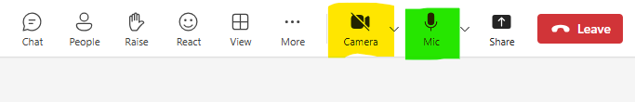

How to join from a smartphone:

If you have never downloaded the ‘teams’ app on your phone start here:
- Download the ‘teams’ app only if you have never done so before.
  - If you have an android, you can find this on the ‘google play store’ app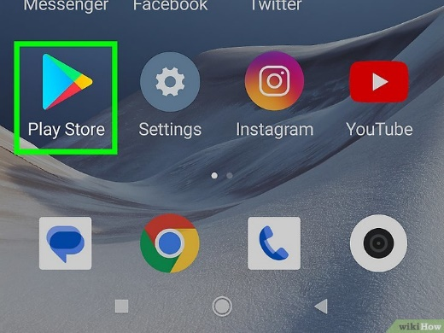
  - If you have an iPhone, it will be the app store

  - The ‘teams’ app icon to download looks like this:

- If you have never created a ‘teams’ account before, open the app and follow the steps on the screen to create an account

If you have the ‘teams app on your phone and have an account created, start here:
- Once you have the app downloaded and a teams account created, navigate on the internet to www.jesusthewholetruth.com
- Click on ‘links to join live’
- Ensure the correct link is clicked (Tuesday and Thursday have different links):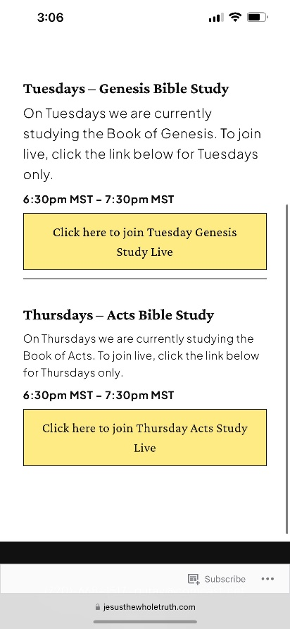

- Once you click the link to join, you will see this notification below, click ‘join event’:


- Then, you may see a notification like this, click ‘open’

- It will take you to the ‘teams’ app to join the meeting, you will see something like the image below, click ‘join now’:
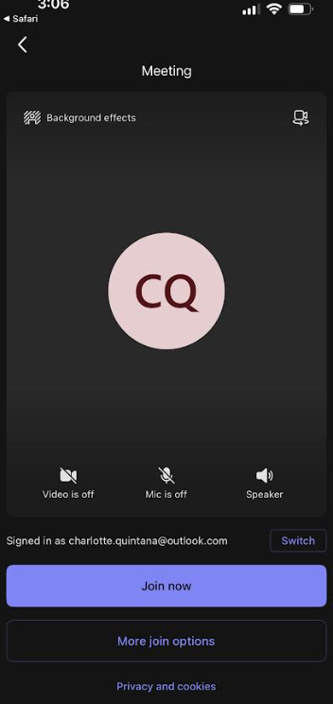

NOTE: how to turn microphone on and off
- Once joined, the highlighted buttons on the bottom of your screen will indicate if your microphone or camera are on:
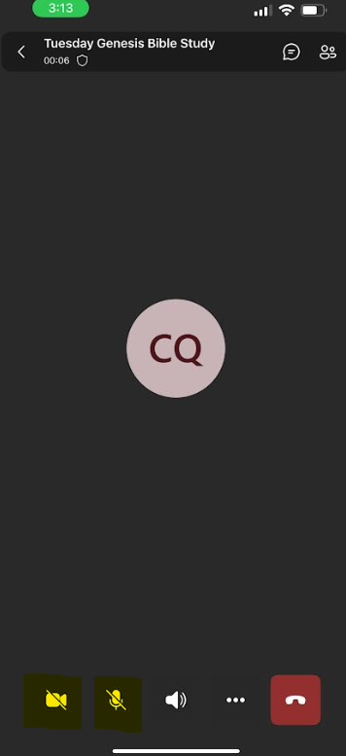

In this image above, the line slashed through shows that my camera and microphone are ‘off’ so no one can hear me. To turn on the mic, simply click it and we will be able to hear you speaking. When your microphone is ‘on’ the buttons will look like the below image:
