The Tabernacle in the Wilderness

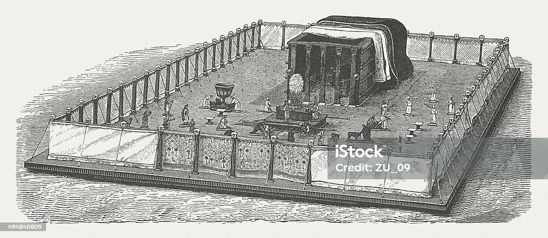

Ark That was inside the Tabernacle Holy Of Holies with the Pot of Manna, Aarons Rod that Budded and the two Tables of stone of the law
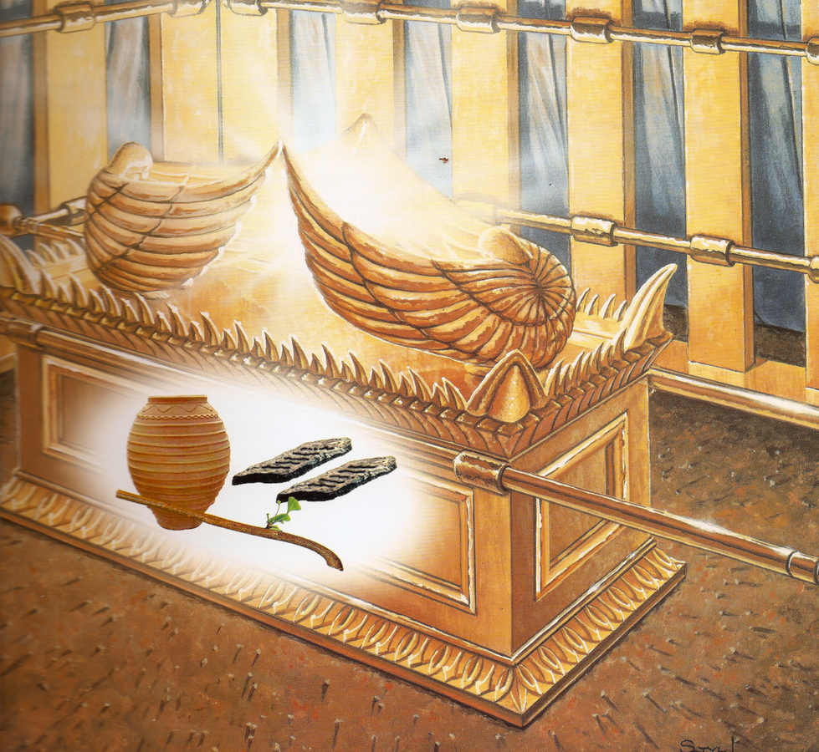

CHRIST TYPIFIED BY THE TABERNACLE’S
FOUR LAYERS OF COVERING

Fine Twined Linen
Now we want to consider the tabernacle’s four layers of covering. The first layer was of fine linen. This was the layer of the most fine material. It was embroidered with beautiful colors: blue, purple, and scarlet. According to the type, blue is heavenly; purple is kingly, royal; and scarlet is redemptive. The fine linen signifies the fine human nature of Christ with His fine character and conduct. It typifies the bountiful, fine humanity of Christ. The four Gospels portray a man whose nature and conduct were exactly like the fine linen. This linen was very strong because it was twined, doubled, strengthened. The Lord Jesus was fine yet strong. Nothing with Him was rough. The fine linen was also embroidered with cherubim, which typify God’s glory magnified in His creation. This means that God’s glory was wrought into Christ’s humanity. With Christ’s fine human nature and character, there was God’s divine glory wrought into His creation. Hebrews 1:3 says that He is the effulgence of God’s glory. He is the brightness of God’s shining. The embroidered cherubim were upon Him. He is not only human but also divine. His human nature bears the divine glory.

Goats’ Hair
The second layer was goats’ hair. In Matthew 25 the Lord divides the sheep from the goats (vv. 32-33). The goats signify sinful persons. Second Corinthians 5:21 says that God made Christ, the One who knew no sin, sin for us. The layer of goats’ hair typifies that Christ was made sin for us. He was like fine linen, but He was made like goats’ hair. With Him there was no sin. He did not know sin, but He was made sin for our redemption.

Rams’ Skins Dyed Red
The third layer was rams’ skins dyed red. A ram is a male, and the dyeing of red signifies the shedding of blood for redemption. This signifies that Christ was slain on the cross, shedding His blood to redeem us from our sins. Thus, the first layer typifies that He was sinless; the second layer typifies that He was made sin for us; and the third layer typifies that He bore our sins and shed His blood to redeem us from our sins. He was the sinless One, but He was made sin for us to bear our sins.

Porpoise or Badger or Seal Skins
The outer covering was porpoise skins, the protection and safeguard for the tabernacle. This layer could withstand any kind of storm or attack. It was very coarse and looked worthless. From the inside the tabernacle looked beautiful and glorious, but from the outside it appeared very coarse. Likewise, Christ did not have a beautiful outward appearance (Isa. 53:2), but within He was divinely beautiful. It is the same with the church. When viewed from the outside by the worldly people, the church seems worthless and coarse like the porpoise skins. But when people come into the church, they will see the beauty and glory of Christ.

The Ark of the Covenant, with Blue Outer Covering
